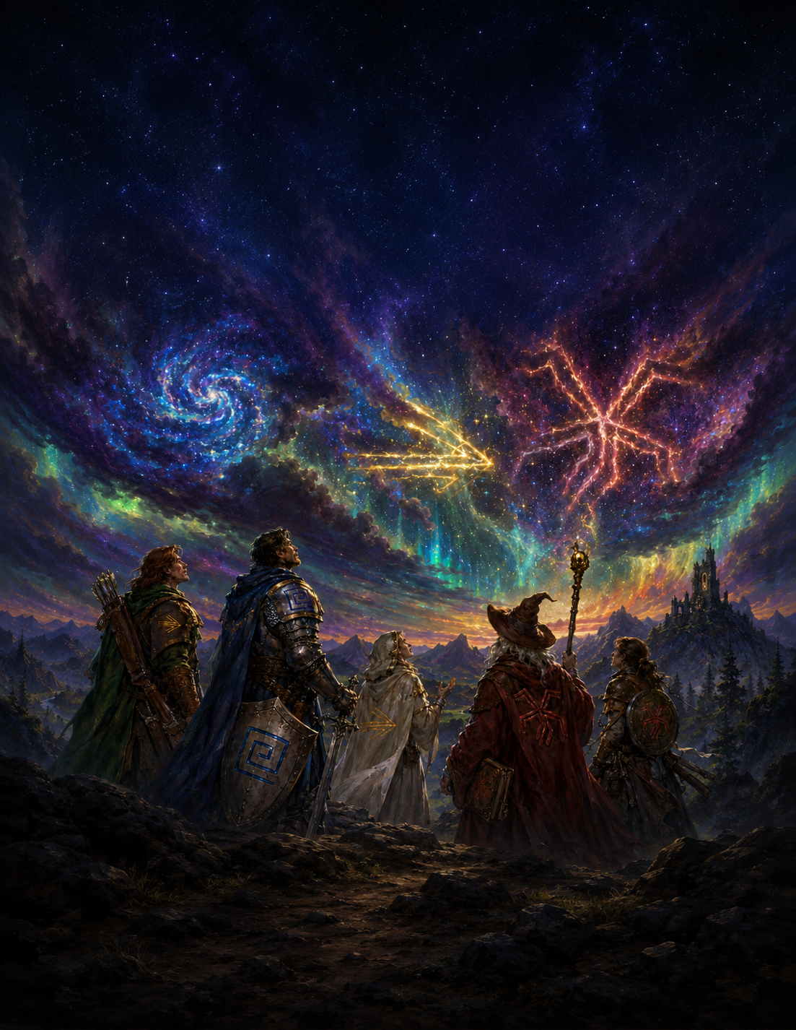
The Realm of Prima
Player Handbook

Prima
Playtest Draft v0.1

A Note on This Document
This is an Early Playtest Draft. Systems, numbers, and terminology are subject to change based on feedback and playtesting. Critique is welcomed!

The artwork in this documentation is a combination of crude sketches, stock art, and AI-Generated Images at this point in the design process. Please note that this is temporary and purely for layout and mood purposes, as a massive wall of text would simply not be pleasant to read. Due to frequent changes and rapid iteration cycles, using handmade art for every piece at this phase in the process would not be possible.
All release art will be original commissioned, vetted, and human hand-drawn work.
Additionally, all ideas and writing come from the brain of the creator first and foremost! Any LLM usage is purely for tedious math, data aggregation, and formatting purposes – the Prismatic System is by humans (Me!) for Humans (You!) and will stay that way
Just to reiterate and be extra clear – zero official, non-draft content will leverage any AI art or writing. The system will be polished by commissioned artists, writers, and passionate community members first and foremost.

Please direct all feedback toward jackvalladares@gmail.com
or join our discord here

Version 0.1 – 5/20/2026

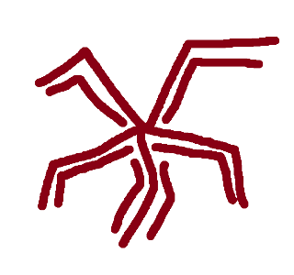
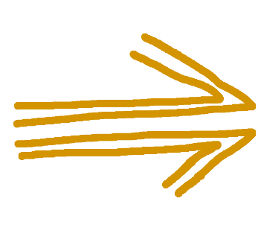

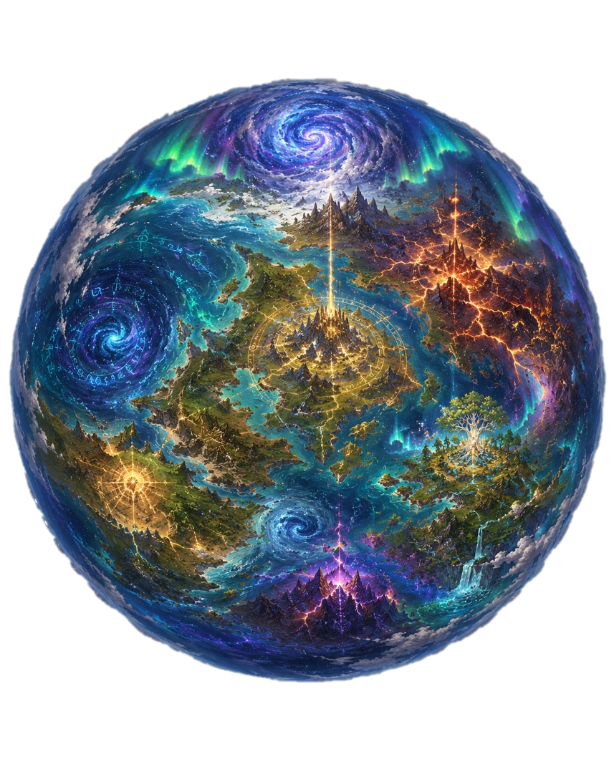
Part 1
The World
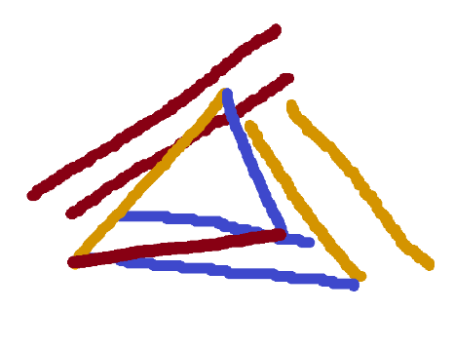
Chapter 1
The Prismatic World
Prima
“The stars are deeply obscured behind a dense wall of clouds in the sky. Despite this, the atmosphere glows with the primal light of creation – twinkling a million different colors above the adventurers’ heads.”
The Prismatic Realms are woven in the language of Prima.
Since the dawn of the very first societies marked by the earliest notches on the timeline, Prima has been observed and understood in many ways under many different names, but a single, universal truth has always been known by all: Prima is energy in its most raw form. Chaotic, Transformative, Constructive; untainted by bias or intent.
This curious substance is said to be cosmic in origin, as it is found in its most dense and pure form the higher one travels into the atmosphere – giving it a religious connotation in many societies. Visually, it presents itself as a white plasma with a deep pearlescent hue – glittering with more colors the more deeply it’s observed. Prima only vaguely interacts with the material world – lightly contorting around and permeating physical objects and feels sterile and vaguely energizing if one were to reach into it.
Prima is as plentiful as it is precious; existing abundantly in the natural world following the natural ebb and flow of any process involving energy. Just as a volcanic eruption or violent ocean storm would be marked by heavy amounts of Prima empowering the phenomenon, so too would it lightly glitter in a gentle breeze on an unremarkable day.
Therefore, a simple axiom is known to all in the Prismatic Realms as common sense – To Exist in the Prismatic Realm is to exist in a World of Prima.
Paradoxically, Prima in this form, despite being so ubiquitous, is more akin to a platonic ideal than an actual tangible thing. To say that a process involves Prima is akin to saying it involves Energy. Is this in the form of heat or electrical energy? Potential or kinetic? Perhaps even centrifugal? While all of these processes are technically energy in different forms, energy is understood to have shape and properties as it exists in the real world. This is also, then, the case with Prima. Pure, pearlescent, cosmic Prima looks nice as a balanced equation or twinkling substance in the stars above, but Prima in the world is stained by intent and bias; imbued with a shape that determines its usefulness. This is known as Prisma.

Prisma
Prima given form is called Prisma. The word itself is a useful shorthand for this concept – where a type of Prisma represents Prima of a particular nature.
This nature is obtained through a process called Staining. Staining occurs whenever Prima interacts with the world and the world, in turn, leaves its mark. A volcanic shelf saturates the Prima above it with heat and force. A glacial basin imposes its patience and weight. A coastal storm charges the air with restless, shifting energy. Prima absorbs all of it indifferently, taking on the character of whatever surrounds it.
Because every granular interaction determines the properties of Prisma, no two samples are identical. All Prisma is fundamentally unique — endlessly stained and molded by the world around it over countless generations. The most un-Stained Prisma can be found in the upper atmosphere approaching the cosmos, yet even there one will observe traces of Staining when viewed closely enough.
The material world, then, is the primary author of Prisma's nature. Its landscapes, its forces, its environments – these are the first and most fundamental stain. This is known as a Prismatic Expression.
Though the world is not the only thing that stains.

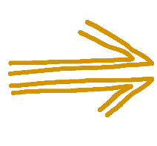
Prismatic Expression
Morphic Prisma
Flow, Change, Movement,
Oceans, Rivers, Adaptability
Prisma is defined first and foremost by its observable form, known as its Expression.
More precisely, the Expression by which Prisma is categorized encompasses its visible color and physical properties as a direct reflection of the environment by which it was stained. Environments rich with Creation, Destruction, and Change all impose a particular type of Expression on the nearby Prisma - and in turn, the Prisma itself acts as a catalyst and visual representation of these very processes.
There are three core phenomena that each create distinct Expressions of Prisma.



The force of Flow represents currents of change made manifest. Oceans, Rivers, Coastlines, and Storms are all agents of flow in the world – moving and morphing the world around them. Flow is fickle, adaptable, and much like the water and lightning that defines it, changes shape to suit the situation it’s in. Flow moves through the world, changing it incidentally.
Prima in environments with large amounts of Flow is stained Yellow – creating what’s called Morphic Prisma.
Morphic Prisma is very malleable, dynamic, and flows around physical matter.

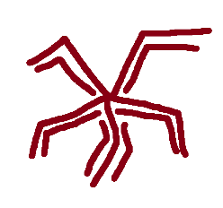
Entropic Prisma
Decay, Destruction, Endings,
Deserts, Magma, Inevitability
The force of Decay represents destruction made honest. Death, decay and destruction as the mechanism through which the world begins anew. Places with active geologic activity as well as Tundras, Deserts, and Wildfires are all agents of Entropy in the world – leveling the world in preparation for new beginnings. Entropy is powerful, honest, and inevitable, and much like the fire that defines it, pierces the world around it.
Prima in environments with large amounts of Entropy is stained Red – creating what’s called Entropic Prisma.
Entropic Prisma is very potent, biting, and pierces the environment around it – sinking through physical matter.

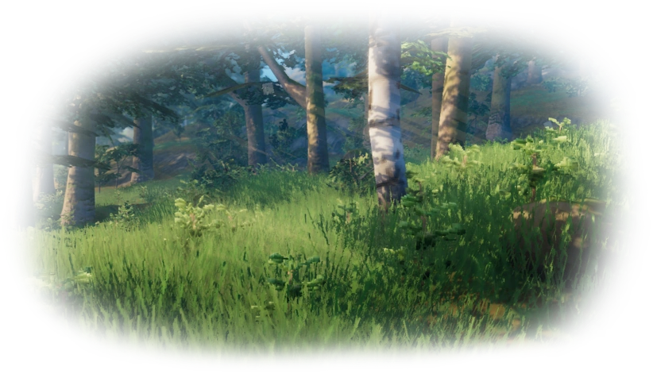
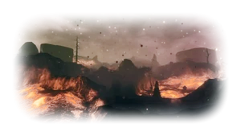


Stratic Prisma
Iteration, Creation, Beginnings,
Forests, Stone, Patience
The force of Iteration represents creation imposed on the world. Forests, Glaciers, Mountains, and Dense Earth are all agents of fabrication in the world – depositing iterative structures into the world over countless aeons. Fabrication is dense, patient, cumulative and much like the stone that defines it, imposes itself on the world around it.
Prima in environments with large amounts of Fabrication is stained Blue – creating what’s called Stratic Prisma.
Stratic Prisma is very dense, and layers itself onto the environment around it – resting atop physical matter.

Flow, Iteration, and Decay – or Change, Creation, and Destruction – are widely recognized as the most basic aspects of the world. An ocean with clear currents of change will likely have a yellow tint imbued into its atmosphere, with frequent storms and morphic Prisma a plenty. This holds true for environments with distinct forces of iteration and decay as well.
Just as no Prisma is truly stained with a single color, so too can trace amounts of Decay and Iteration be found in even the most Morphic of seas; the yellow environment with its yellow Prisma simply indicates Flow as the dominant force – and thus, dominant Expression.

Composite Expression
Though all environments have trace amounts of every Expression Environments where two dominant forces act in equal measure produce something neither force creates alone.
This may be in the form of an environment such as a seaside volcano representing simultaneous Decay and Flow. In such a region, whose Prisma has a roughly equivalent Red and Yellow Expression, the Prisma would take on a visible Orange color – representing Force as intersecting forces of Change and Destruction.
These expressions are considered Higher Order, or Composite Prisma - and are more uncommon than Lower-Order Expressions. These are as follows:


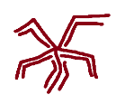

Prisma with an Expression representing equal parts Decay and Iteration is known as Cyclical Prisma, representing Flux as the forces of Creation and Destruction in tandem.
Cyclical Prisma
Flux
Cyclical Regions are those where iterative, constructive Stratic environments clash with decaying, destructive Entropic ones. This might be an ancient forest whose ecosystem practically relies on frequent wildfires, or volcanic mountains whose peaks are the result of millions of years of dried magma. Subtler Cyclical Regions are far more common than their dramatic counterparts — the Boreal Taiga, whose dense forests grow patiently at the very threshold of survival atop frozen, decaying earth, or the great Savannahs, whose grasslands burn and regrow in seasonal rhythm. In these places the cycle turns quietly, measured in seasons and centuries rather than eruptions.
Cyclical Prisma is distinctly Purple and takes on natures of both its components - dense and potent, bobbing just along the surface of physical matter…sinking into it before hovering above.




Prisma with an Expression representing equal parts Flow and Iteration is known as Disruptive Prisma, embodying Foment as the proliferation of change imposed upon the world.
Disruptive Prisma
Foment
Disruptive Regions are where the world's oldest things meet its most fluid. This might be a powerful river that carves through a forest, a coral reef that finds order and structure among the tides, or a Jungle along a coastline – whose towering trees are subject to powerful monsoons and the chaos of its own ecosystem. A keen observer will note that even modest Disruptive Regions carry a faint strangeness - a reef just slightly more maze-like than it ought to be, a riverside forest whose paths never quite match one's memory of them.
Disruptive Prisma is distinctly Green and takes on natures of both its components – sturdy-yet-malleable, with a slight resistance but ultimately taking on the shape of its container.

Prisma with an Expression representing equal parts Decay and Flow is known as Surging Prisma, embodying Fervor as powerful destructive force moving along natural currents of momentum.
Surging Regions are where the world's most kinetic forces collide and consume. This might be in the form of an oceanic volcano or mangrove forest whose unique and wonderous ecosystem lies at the intersection of oceanic currents and swampy decay. The largest Surging Regions are the Elemental Seas - vast stretches of ocean where current and consumption act as one, navigable to those with the strength and nerve for it, and the most dangerous trade routes in the known world.
Surging Prisma is distinctly Orange and takes on the natures of both its components – fluid-yet-piercing, following its own currents of momentum through and around physical matter.

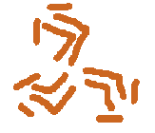


Surging Prisma
Fervor
These Higher-Order Expressions develop naturally in the world over aeons, and their corresponding environments represent an intricate homeostasis between the natural forces of the world – where a Cove of Mangroves, Wildfire-Enriched Forest, or Flourishing Coral Reef is each its own delicate and rare natural wonder.
Higher-Order Expressions can also be the result of Prismatic Whiplash, representing an environment thrown into total disarray. If an Invasive Species were to force large populations of Fabric beasts into an Entropic region, the ecosystem and landscape might be thrown into disarray – causing unnatural cycles of proliferation and collapse. This Cyclical Prisma would arise from the perverse side of its underlying principle, representing a Purple as the Tension between Red and Blue instead of its synergy.
The most extreme example of this tends to result from the intervention of humans and other sentient beings – where a Stratic kingdom might realize that importing large amounts of laborers attuned to Surging Prisma alongside huge vats of bright supercharges their production. Orange Prisma here could pollute the waterways and mutate local wildlife as towering smokestacks pump its residue into the region.
Though most Higher-Order environments exist along the borders of Lower-Order Expressions as composites – such as a Taiga between a Forest and a Tundra – particularly strong overlaps over aeons of time create particularly mystical and dangerous environments with Higher-Order Prisma greater than the sum of its two parts.
In such a case, a Disruptive Jungle might evolve from a simple Blue/Yellow Overlap – the simple intersection of Flow and Creation – into an environment that embodies Foment run Rampant.
The most iconic example of such a place is known as a Verdant Maze – an environment of endless proliferation, deeply removed from an Entropy to temper its growth. Verdant Maze regions grow beyond the boundaries of space itself – where its landscape becomes non-Euclidian in nature, where maps are worthless and distance itself is meaningless in concept. The Green creatures here evolve rapidly, with biology that seems arcane in nature.
Environments such as Verdant Maze Regions are broadly known as Prismatic Wilds, and in contrast to Lower-Order environments, which are largely defined by civilization and mundane geology and ecosystems, are largely unsettled and dominated by Flora, Fauna, and the Whims of Prisma itself.
Prismatic Wilds are dangerous, and proper traversal requires heavy preparation and skill – and even then, there is no guarantee of a safe voyage.

Prismatic Beings
One more important principle to formalize is Prismatic Expression in the context of living organisms.

All Creatures in the Prismatic Realm have bodies and souls imbued with Prisma. The Body’s natural processes are fueled with Prisma just as naturally as they are food and water, and so too is its Prisma stained by the body’s form and function.

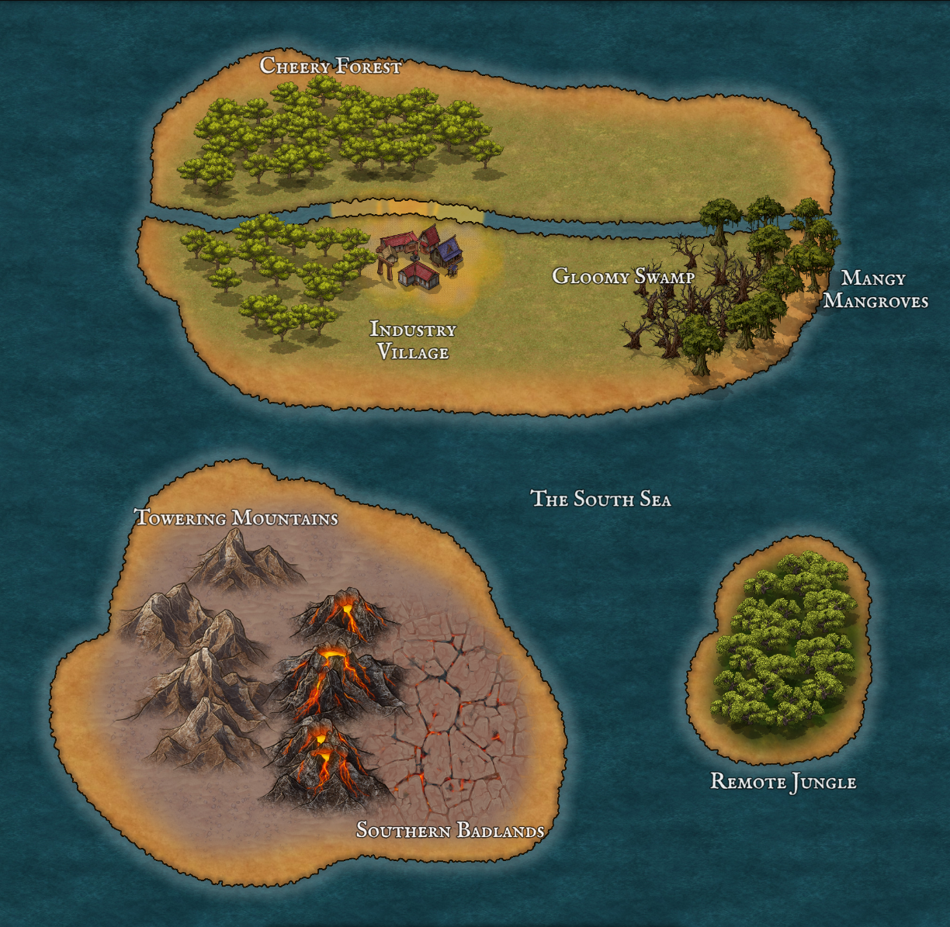
Take a look at this simple example map. Notice the forest to the Northwest as well as the river that runs through the landscape, and then the nearby village alongside a crude orange landscape and waterway. This represents a Fabric Forest with Innovative Prisma where it meets the river. This village – “Industry Village” – represents our example where a Green Society imports unnatural Orange Prisma and causes Prismatic Whiplash in its environment To the Southwest we have “Gloomy Swamp”, a distinctly Entropic environment that transitions into “Mangy Mangroves” – a Forceful Environment along the coast. Compare this to the perverse orange surrounding the Industry village that acts as a discordant stain on the map and environment alike
To the Southeast, we have the “Towering Mountains” – another Fabric Environment – and the Volcanic Southern Badlands, an Entropic one. These intersect to create a Cyclical Environment in between where the Mountains between more Volcanic themselves.
Finally, we have the “Remote Jungle”, a natural Innovative environment where the Jungle represents a potent natural blend of Fabric and Morphic Prisma.
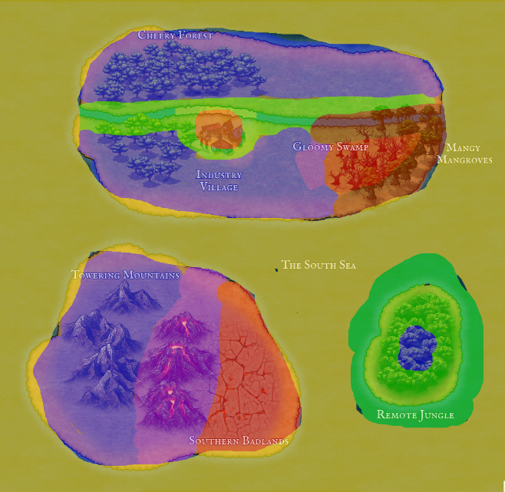
Here is that same map with a crude Prismatic Overlay.
Notice the ocean as a large Yellow Blob, as oceanic environments are Morphic by default. While Blue and Red coastlines can be distinctly Orange or Green, such as the Mangy Mangroves, this might be too marginal to observe on a map.
The river cutting through the northern landmass, on the other hand, is distinctly green and orange, as rivers tend to represent a very potent Morphic skew in the areas they cut into. The Orange blob and segment of the river representing the perverse Orange Prisma as a result of industry.
The southwestern landmass, by contrast, is a wholly natural gradient between mountain, volcano, and badland – with a clear blue/purple/red transition along the way.
Finally, we can see the predominantly green jungle to the southeast with some blue toward its center.
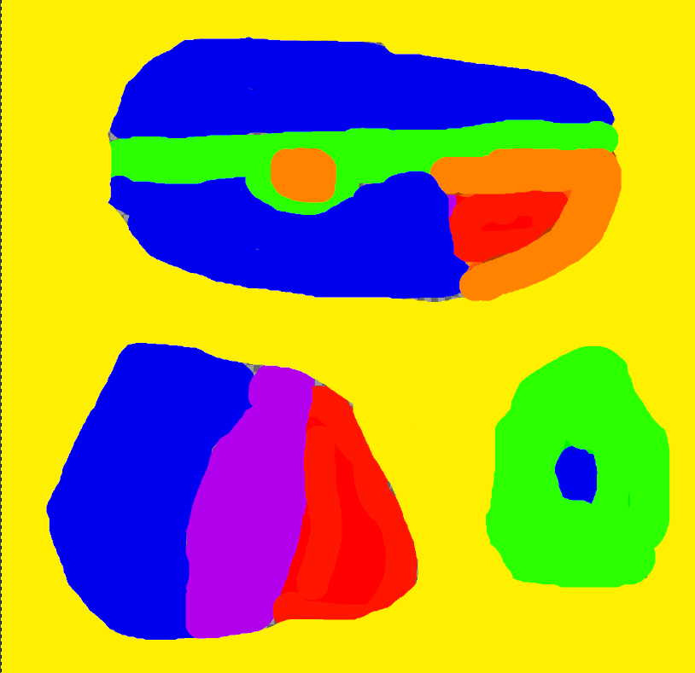
Even if we remove the underlying map entirely, an understanding of Prismatic Expression allows an observer to roughly approximate a region’s landscape entirely devoid of context.
The Sharp Green and Orange Lines, for example, are a clear indicator of a sharp Morphic Current – most commonly represented by moving water – cutting through a red or blue landscape. The big red blob surrounded in orange, by extension, is likely some kind of desert or swamp that organically interacts with the nearby bodies of water.
The blue/purple/red is likely some kind of stable Forest/Savannah/Desert or Mountain/Volcano/Badlands gradient, interacting with each other more-so than the surrounding ocean
Then, the green island is some kind of forest, reef, or mountain environment with such an Innovative identity that it’s hard to identify precisely where the Morphic influences end and Fabric begin.

\

Prisma, however, is not only stained by material forces. Ideas themselves — philosophy, culture, belief — impose a second layer of staining onto Prisma already shaped by its environment. This is called Inflection.
While Flow, Decay, and Iteration are considered fundamental, material agents of the world – culture and ideas are arbitrary, subjective and transient. The idea of “Dawn”, for example, is widely considered the “beginning of the day” in modern society – a bright beginning to a new day. But a nocturnal society of old might have considered “Dawn” to be a blinding end to a comforting night – an entirely different subjective understanding of the same concept.

The process of Staining Prisma, however, does not care about this subjectivity. A culture that reveres the Dawn as a divine agent of healing still Stains Prisma with exactly that concept – and the region’s Prisma will nonetheless be stained by concept.
In the case of Dawn as an idea, though all of the Prisma will have a Morphic, Entropic, or Fabric Expression First and Foremost – the philosophical Dawn inflection imposed upon it will further impact its nature, becoming Bright Prisma. In this case, it would be more saturated and immaterial, with a healing and energizing warmth imbued within.

The force of Flow embodies the Inspiration of Dawn. This Prisma is bright yellow, refracting through the air, and imposes the Dawn's promise onto the world – filling allies with the clarity and momentum that comes with a new day.
The force of Entropy embodies the Judgement of Dawn. This Prisma is bright red, scorching hot, and imposes the Dawn's verdict onto the world – channeling powerful smites that strike fear into all manner of nocturnal evildoer.

The force of Fabrication embodies the Restoration of Dawn. This Prisma is bright blue, comfortingly warm, and imposes the Dawn's Restoration onto the world – bolstering bodies and spirits, returning them to wholeness against all manner of darkness.

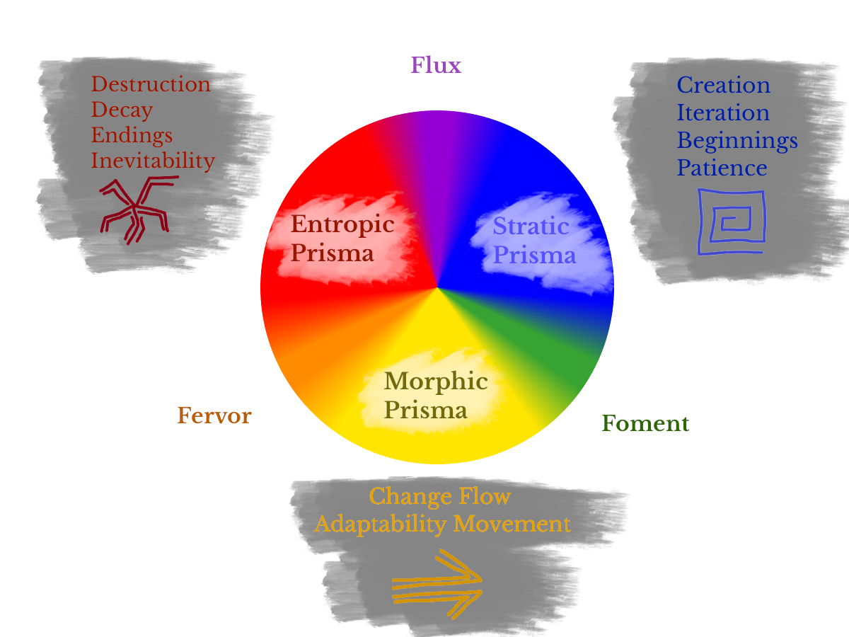

Thus, a region with a strong tie to the idea of Dawn still has Morphic, Entropic, and Fabric Prisma as the world’s Fundamental Governing forces, but the shared cultural tints these expressions to take on different meanings. The Rivers flow with Bright Morphic Prisma, bright and saturated, known to be refreshing and provide clarity. The Bright Fabric forests are full of vitality, with local flora being widely edible and restorative. The Bright Entropic volcanoes run extra hot, with ores that smelt into metals that are particularly effective against the werewolves and vampires that created such a positive association with Dawn in the first place.

Though even a single thought technically Stains the Prisma of an area, it requires the shared collective thoughts of an entire culture to prominently stain it in such a way that a clear Inflection is imposed upon the world in this manner. The Prisma of each region is most commonly associated with the two most prominent ideas held among its population. Therefore, if this society that revered the Dawn was also home to a large number of Scholarly Wizards, it might also take on Arcane Properties as a secondary axis, with the environment reflecting qualities of each.

Prismatic Domains
Each recognized Inflection is known as a Prismatic Domain – with each resultant Expression of Prisma being a Subdomain.

In the example discussed, Bright Prisma falls within the Dawn Domain.
The Subdomains of Dawn are, then, Inspiration, Judgement, and Restoration – describing expressions of Flow, Entropy, and Fabrication with a Dawn Inflection.

Because a Prismatic Domain arises when enough collective cultural ideas and values become prominent enough to create a visibly new form of Prisma, each Domain naturally has a Domain Relationship with the others. Cultures that value the night - stealthy, private, and shady - stain the surrounding Prisma in the form of Dark Prisma, which is known as the Dusk Domain. The Dusk domain, of course, has its own Subdomains in the forms of Guile, Hex, Shroud.
Even before taking Prisma into account, an idealistic society of abundance that operates earnestly in the world is naturally opposed to one so private, self-sufficient, and unsentimental. The two Domains are simply an extension of this same conflict.
Domains with this type of relationship are known as Opposed Domains, with the particular example of Bright and Dark Prisma being an example of Diametrically Opposed Domains – considered polar opposites.
Domains with similar, overlapping philosophies are known as Resonant Domains.
The Arcana Domain with its Arcane Prisma as the representation of unbiased, scholarly understanding is Resonant with Bright and Dark Prisma – as the Dusk Domain appreciates the cynical, unbiased facts native to Arcane understanding, and the Dawn Domain appreciates the Arcane trait of shedding light on the world’s secrets

Each Domain, by this principle, has natural enemies and allies unique to its underlying ideological qualities.

These relationships also serve as a heuristic for how difficult it is to gain a mastery of a particular Prismatic Domain – where learning even basic Dusk principle would require an entire mindset shift for one whose personality was shaped by Dawn. Inversely, one who sees the world through an Arcane lens would have no trouble picking up several principles of Dusk’s philosophy.

Channeling Prisma
The art of using and manipulating Prisma – both external and from within – is known as Channeling.
The term is a very broad umbrella that covers a wide range of applications such as spellcasting, artifice, alchemy, capture, storage, and even meditation.
If Prisma is moved, manipulated, imbued, or spent – it is being channeled.
Because the bodies and souls of living beings are imbued with Prisma, Prisma can be channeled using the self as a focus. One’s own Prisma can be Stained and molded by their intent and then imbued into their body or evoked into the world in the form of powerful spells and abilities.
Deeper understanding of oneself and one’s own Prisma makes the process more efficient and potent, where more advanced Channelers are able to shape their Prisma in increasingly complex and sophisticated ways; twisting their Prisma output to just the right color and nature for specific use-cases. Novice-level channelers, in contrast, waste large amounts of Prisma attempting to do the same.
Prisma is also channeled through external artifice depending on the context and goals.
These external means of Channeling Prisma might take the form of spellcasting focuses that assist in the process of staining one’s own Prisma. This might also be represented by Gear powered by one’s own Prisma output such as weapons, armor, and vehicles. The spectrum of Prismatic Engineering is as vast as it is useful, and throughout the broader world ranges from simple household appliances and Prismatic Batteries to sprawling kingdoms with sophisticated Prismatic Infrastructure and War Machines.
Those who choose to immerse themselves in lifelong pursuit of Prismatic Understanding - living exceptional lives of expertise and a deep exploration of self - are referred to as Channelers. The different classes of Channelers, such as a Dusk Hexmage who uses Prisma to inflict curses or an Artificer who uses it to enchant armor and weapons, are referred to as Archetypes.
Therefore, every channeler belongs to some kind of Archetype describing their general skillset.
The first, most fundamental step to becoming a Channeler is figuring out the nature of one’s own Body and Soul. That is – their own Prismatic makeup, as unique as fingerprints upon one’s own fingers. Understanding your Prisma allows you to understand your strengths and weaknesses as a Channeler.

Prismatic Fingerprints
Societies in the Prismatic Realm are able to reliably map out the Expression of one’s soul down to a science.
The exact methodology will be more extensively covered in the chapter Harnessing Prisma through Artifice and Alchemy. However, a basic outline of this process is key to understanding the nature of the Soul as a Prismatic Entity.
To start – a Prismatic Fingerprint is an approximate Snapshot of the Soul’s Prisma.
Intent and Bias reflect one’s Personality and Body, which themselves are very fickle and subject to change over the course of a lifetime. Thus, this Fingerprint shifts over the course of many people’s lives – particularly the life of a practiced channeler whose relationship with Prisma is constantly shifting.
The Prismatic Fingerprint is measured by placing one’s hand on something called a Prismatic Easel – a paper-like substance that reflects core Expression when it comes into contact with dense Prisma. This is done intentionally as a rite-of-passage in most societies, where one places their hand upon an Easel and directs willpower outward to dye it with their own Prisma. The easels used in this process are precise enough to determine a color ratio in fifths.
The standard unit of Measurement for Prisma was derived this way, where an Inkling of Prisma is equivalent to one fifth the amount of used in the Staining Process.
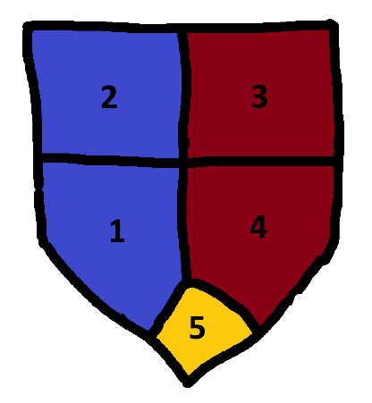
Every traditional manner of Channeling from Artifice to Spellcasting to Storage and Transport measures Prisma in Inklings as a foundational unit, thanks to the Dyeing of the Easel being one of the earliest and most rudimentary forms of Channeling discovered.
After an Easel is successfully Dyed, the easel paper is encased in an Insulating Resin (again – covered in the chapter on Harnessing Prisma through Artifice and Alchemy) and converted into a Prismatic Crest denoting one’s Fingerprint.
The ratio of colors making up the Crest are known as one’s Attunement.
Crests are most often depicted by a shield divided into five segments (as pictured above). Many, though, get creative with the process and create unique crests such as a tree with 5 differently colored leaves or a five-pointed star. Noble Family Lineages will often adopt a corresponding Crest and see it as a point of Pride when descendants carry on the family’s Attunement.
A Prismatic Attunement – and thus, a Crest - follows a specific naming scheme across cultures and societies. One’s dominant color is known as one’s Aspect, and the secondary color is their Tint. Any color represented by a single segment –such as the yellow one pictured – is known as a Hue.
An equal ratio of two colors is called a Dual-Aspect, signaling an affinity for two different Prismatic Expressions.
The Crest Pictured, according to this schema, has a Red and Blue Dual-Aspect with a Yellow Hue. This means that the soul carrying this attunement is well-suited to channeling their preferred Domains’ Fabric and Entropic Prisma. A Paladin channeling Bright Prisma with such a Crest would leverage particularly potent Smites within the subdomain of Judgement and healing by virtue of Restoration spells.

Understanding which colors your soul is attuned to is key to understanding how to best leverage your preferred Domains. Though the Paladin above would still have full access the Inspiration subdomain even without a single yellow Inkling, it would not be as much a distinguishing talent as Judgement or Restoration
Categorizing Domains
Chapter 2
Domains in Detail
As we have discussed, a Prismatic Domain is the result of a fundamental Prismatic Expression of the world’s forces imbued with cultural and philosophical concepts.

These Domains are Transient and plentiful – shifting with understanding of the world across ages.
This transience may be in the form of the domain itself changing over time – where Dawn’s lost Heat sub-domain transitioned to Judgement in the era of Vampires, Werewolves, and other nighttime Fiends, now acting as a vestigial aspect of the smites therewithin.
This is also represented by modern understanding of various concepts rendering archaic ones outdated – such the long-lost Weapon Domain’s crude Warlike Prisma being lost in favor of more specialized modern martial techniques being spread across Nimble, Versatile, and Blunt Prismatic Domains.
Finally, this comes in form of entirely new concepts creating wholly unique new Prismatic Domains and one ones being completely lost to time. This is very common in the form of long-lost deities and philosophies being tied to some sort of ancient Domain, and the Age of Engineering, Alchemy, and Spellcraft birthing the Artifice Domain’s Crafty Prisma.

All Domains – and by that measure, their underlying ideas – are also measured by their MIND/MATTER Alignment.
MIND represents abstract and immaterial concepts. This includes ideas such as transmutation of natural elements (fire, ice, electricity), dusk, and dawn. MIND Domains carry with them spellcasting and are amplified by one’s willpower, mental wit, and focus of mind.
MATTER represents concrete and worldly concepts. This includes physical interaction with the world (swinging a sword or axe, firing a crossbow) and skills pertaining to one’s own body. MATTER Domains carry with them techniques and abilities imbuing Prisma into the self, amplified by one’s athleticism, physical aptitude, and fortitude of body.
The MIND/MATTER split, as with all things pertaining to Prismatic Inflection, is largely arbitrary.
A spear made of icicles is, of course, a physical construct interacting physically with the world. But years of cultural weight and storytelling has embedded the idea of a magician conjuring ice from thin air as a feat of the mind – wielding immaterial magic derived from one’s own thoughts.
Inversely, a martial technique such as swinging a sword could very easily be seen as the abstract concept of swordsmanship, but this too carries cultural baggage. A knight cleaving into a foe is defined largely by a mundane being cutting through a material set of armor – thus carrying with it the MATTER designation.
These concepts are self-reinforcing, and through this feedback loop, ultimately governed by the aspects of self utilized in effectively channeling via MIND or MATTER.

Several Domains fall outside of this neat binary, known as LIMINAL spellcasting domains.
LIMINAL Domains can appear in the form of Hybrids - where Nature’s Primal Techniques interface with both MIND and MATTER principles – imbuing a Barbarian with a Primal Rage in his material Body as well as summoning plant life from thin air. LIMINAL Domains such as Nature with both MIND and MATTER properties are known as Hybrid Domains.
The LIMINAL designation also denotes a Domain that is entirely represented by its relationships with other domains. The aforementioned Artifice, for example, lacks a traditional list of spells or martial techniques leveraged via Crafty Prisma. Instead, this Domain’s Crafty Prisma on its own allows a Channeler to replicate other techniques and spells through advanced alchemy, spellcraft, and artifice. It also, when it appears alongside another Domain’s Prisma, manipulates that Prisma in weird ways.
As an example – the Element Domain normally allows a Caster to inflict Burn, Stun, and Freeze effects through Fire, Electricity, and Ice spells. When Artifice appears alongside the Element Domain, the Crafty Prisma augments the Elemental Prisma to where the Fire and Ice inflict Frostburn through rapid Transmutation.
LIMINAL Domains such as Artifice that serve to question and manipulate the paradigms of others are known as Augmenting Domains. These Domains arise from cultures that question and innovate on Prismatic understanding itself – where the Transmutational effects such as Frostburn is the natural conclusion that comes from applying engineering and innovation to the world’s elements.

Finally, note that the list of commonly recognized Domains is far from exhaustive. Remote regions of the world have entirely unique inflections that Stain Prisma in every countless different ways. Moving along the wheel of time into the distant past or far future might in fact render it entirely inaccurate.

Assigning Domains
When you read through the list of recognized Domains further ahead, it is important to note that the essences of cultures and channelers alike are all represented by their two most dominant inflections.

Though a living soul is endlessly complex and a kingdom can be home to an endlessly diverse array of denizens, the two most prominent Domains represented are able to accurately describe one’s overall nature and personality. If a Channeler whose Prisma is tinted with Bright and Primal inflections were to be put under a microscope, there is a good chance that their personality would align with many Arcane traits thanks to the resonance between their Bright and Arcane qualities – likely even wielding some spells from the Arcana Domain picked up during their travels. But the Designation of Dawn carries all of these implications implicitly, and thus it would be redundant to endlessly map out inflection to a hundredth of a percent.

Commonly Recognized Domains

Elemental is Prisma stained by Cultures who
MIND
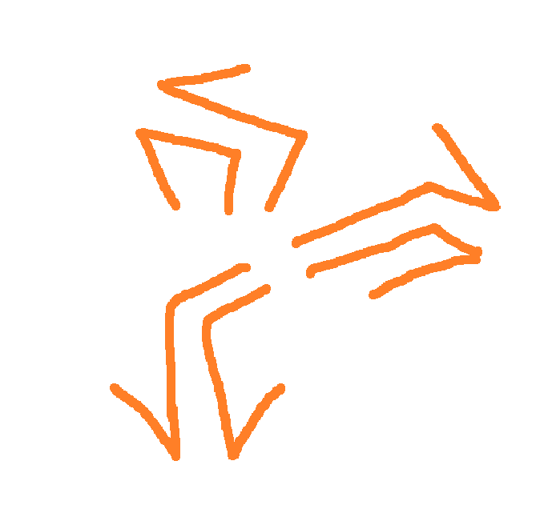
Element (Elemental Prisma)
Philosophy: The concept of natural elements such as Fire, Ice, and Lightning and the relationship between them

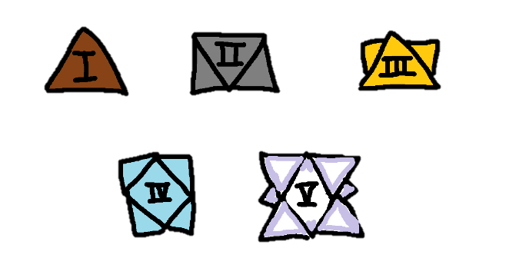
Chapter 3
The World’s Tiers
Tiers of Mastery
Most Channelers never leave Novice.

This is not a tragedy. A Novice Channeler is capable of deeds that would seem impossible to someone who has never touched Prisma at all – likely going on adventures and learning much about themselves in the process. A Novice Channeler can be a hero of their town, or an Artificer with a very profitable workshop – leading a content life with a very useful and rewarding skillset.
But the type of Channelers who shape History – the Legendary casters and warriors who form kingdoms and challenge Gods – walk a long, arduous path that most do not see the end of.
This journey is one as old as time, and as it is well-trodden over the aeons, society at large has recognized Five Distinct Tiers of Prismatic Mastery across Channelers.
These Tiers of Progression all immediately signal the prestige and power of a given Channeler, and Guilds exist to officiate and document this progress among recognized Channelers, with a robust network across the world.
Thanks to these efforts, a party of Channelers with Novice-Level badges can travel across a continent to a remote and foreign town, and its residents will understand immediately their prestige, power, and what they can offer them. This holds true across the spectrum: those who carry Paragon Designation are hailed as celebrities and heroes wherever they go. In a City Besieged by an Ancient Divine Dragon, it is common knowledge that the first thing to do is seek out a Channeler of this status – and pray they arrive in time.
Tiers describe Channelers first and foremost. Though, as Channelers are often on the frontlines against the world’s Creatures and Threats and mastering particular spells and weapons at predictable levels of mastery, many other things are “ranked” with this same system.

Hostile Creatures have Tiers corresponding with the level of Channeler that stands a chance against them. A Creature being classified as Tier II, or Journeyman-Level, requires at least a Journeyman-level Party to defeat on a level playing field.
A Tier I Novice-Level Party of Adventurers would be at a heavy disadvantage on a level playing field, and a Tier III+ Party would handle this creature with ease. This allows settlements to properly call in help and assign quests to properly equipped Channelers.
Weapons and Spells are Described by the tier of Mastery expected to properly wield them.
A Prismatic Spell is determined to be Journeyman-Level when the amount of Prisma required corresponds roughly to a Journeyman-Level Channeler’s expected output.
This is not a hard-and-fast rule, of course, and the designation also serves as a great heuristic for ascertaining the proficiencies of a particular Archetype and Channeler. A Novice Minstrel, for example, might have the skill to cast Journeyman-Level Charms thanks to being particularly talented at casting Charms. Inversely, this same Minstrel might graduate to Journeyman level and still rely on Novice-Level Evocations as a backup option.
Martial Abilities operate on a similar axis, but mundane weapons do not themselves carry a Tier Designation. Instead, Tiers are applied to Proficiencies and Techniques. A Novice and a Virtuoso Barbarian, then, both likely able to wield the same Battleaxe and use it to rout foes with no issues. The Virtuoso Barbarian, however, has Virtuoso-level Proficiency with the weapon - and thanks to mastery of the self and their corresponding Prisma, swings it with a much greater deal of potency and consistency, cleaving it through multiple foes at a time and cutting off limbs in the process. As with spellcasting, one with particular talent for a specific weapon might achieve a higher tier’s abilities earlier, and a mage wielding a dagger as a sidearm might swing it with Novice-Level abilities despite being a Channeler of the Master Tier.
What follows is a description of each Tier as recognized by the Guild — what they mean, what they demand, and what they promise to those who earn them.

Each Tier in Detail
Novice Tier
The Novice Tier is the first step of every Channeler's journey. Denoted by a simple Copper Badge, Novice Channelers commit to a basic Archetype and begin learning the fundamentals of Prismatic Mastery.
Novices are the most plentiful Channelers in the world, of wildly varying aptitude, and carry the quiet prestige that comes simply from being a Channeler at all. They are the local do-gooders — the defenders of a small town, the apprentices of an established workshop — working toward the skill and reputation required to earn their next designation.
Novice-tier threats are common nuisances: the kind of danger a village can name and live alongside but not ignore indefinitely.

Journeyman Tier
The Journeyman Tier is the first designation earned through demonstrable feats of skill and mastery. Denoted by a fine Silver Badge, Journeyman Channelers are considered capable and committed past the early stumbling of Novice work and actively refining their craft.
The Journeyman Tier serves to filter out the mediocre and noncommittal and is consequently far less common than Novice. Most settlements have a healthy but limited number of Channelers at this level - enough to be relied upon, not enough to be taken for granted. Journeyman designation carries real prestige: the mark of someone skilled and dependable, if not yet remarkable.
Journeyman-tier threats move beyond nuisance into genuine danger, putting local livelihoods and safety at risk. These Channelers are working toward becoming the hero a town remembers or building a name for themselves in the wider world.

Adept Tier
The Adept Tier is the second designation earned through demonstrable feats of skill and mastery - and the first that cannot be reached by talent and determination alone. Denoted by a beautifully crafted golden badge, individually serialized and registered with the Guild, no two are quite alike. An Adept Badge is immediately recognizable as something earned rather than bestowed, and those who wear one have faced trials that most Journeymen never survive intact.
The Adept Tier is a major threshold in a Channeler's journey, achieved only by a fraction of Journeymen who possess not merely the ambition to push further, but the rare combination of skill, resilience, and mastery to actually arrive. Most settlements hold their Adept Channelers in deep regard - treating them as pillars of their communities - sought after as mentors, leaders, and authorities in battle, craftsmanship, and scholarship alike.
For most ambitious Channelers, Adept is where the journey ends — and it is no small thing. Those who reach this tier and choose to remain have lived full and remarkable lives by any measure. The gap between Adept and what lies beyond is wider than any crossed before it: a reminder that the path does not simply continue, it steepens.
The Adept Tier is where most ambitious Channelers terminate their journey, and those who stay at this level are considered to have had a robust, successful journey across their lives. The gap of skill between this tier and the next is far greater than those previous.
Adept-tier threats are urgent and threaten entire settlements or large pieces of infrastructure. These Channelers are working toward becoming a local legend or bolstering their already glowing reputation in the wider world.


Virtuoso Tier
The Virtuoso Tier is the first designation that graduates a Channeler from local recognition to a chapter in a History Book. This designation's badge is unlike any other - crafted with gemstone hues unique to the bearer's craft and character, richly inscribed in a design that could belong to no one else. Guilds across the world maintain records of every living Virtuoso, and the list is never long.
Achieving Virtuoso designation is considered a profound honor, obtained only through acts of remarkable heroism and skill that strain the boundaries of what most believe possible. Small settlements rarely count a Virtuoso among their residents - and those that do consider themselves extraordinarily fortunate. Where a Virtuoso lives, they lead: as head of the guard, headmaster of a university, or simply the person a community turns to when nothing else will suffice. They are local legends who bring prestige to a place by the simple fact of calling it home.
Reaching the Virtuoso Tier is widely regarded as the mark of a life genuinely well-lived - a destination most Channelers would be honored to call their own. The gap between this tier and the next is vast and largely uncharted, requiring not just exceptional skill but the kind of generational talent that appears perhaps once in an age.
Virtuoso-tier threats are rare and severe - the kind that topple governments and leave scars on the land itself. Facing one without Virtuoso-level capability is considered deeply reckless. These Channelers work toward the rarest of distinctions: a name known not just across the world, but across generations.


Paragon Tier
The Paragon Tier is the highest designation among Channelers — the mark of a truly generational name, known not just across the world but across time. Paragon Badges are small vessels forged from cosmic materials, carrying exceedingly rare Prisma that borders on pure Prima, tinted only by the faintest hue of the bearer's own soul. No Guild registry tracks them. No introduction is required. The name arrives before the person does.
Paragon Channelers serve as the platonic ideal of their Archetype — so completely that their unique journey and relationship with Prisma often forms the foundation of the spellbooks and fighting styles practiced by aspiring Channelers for generations after. Each Archetype is associated with at least one Paragon whose path became the map others follow.
Paragons tend to reside in one of two places: the most prestigious and powerful kingdoms in the world, which court them as living symbols of national identity — or small, unremarkable villages that find themselves suddenly and permanently on the map as the birthplace of a legend. The distance between Virtuoso and Paragon is not a gap so much as a threshold of a different kind entirely. Most continents count their living Paragons on one hand.
Paragon-tier threats are named. They are the kind that do not merely endanger settlements or reshape regions, but they threaten the continuity of the age itself, and their defeat or containment becomes the event that future generations use to mark time. These Channelers tend to conclude their journey not with a personal achievement, but a civilizational one: a new fighting style that rewrites how a weapon is understood, a category of spells that didn't exist before they imagined it, or a technology that permanently changes what the world believes is possible.

Your Character as a Novice
Every channeler in this book - every hero, villain, and legend described in these pages – begins exactly where you are about to begin: as a Novice.

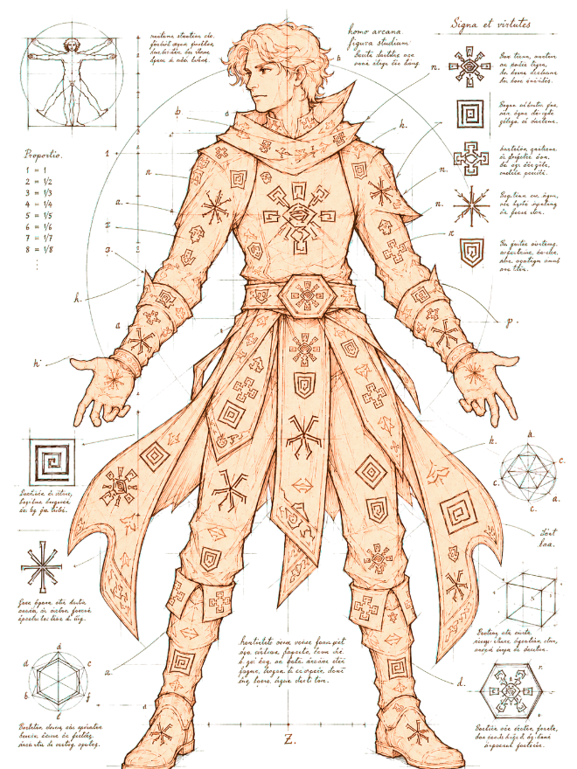
Mind Over Matter
Part 2
Your Character
Chapter 1
Mind and Matter
Though one’s Prisma makeup is a fundamental aspect of being, there are many other aspects of a Channeler worth considering in the process of navigating the world. A person’s Physical Capability, Mental Sharpness, and Resilience to the world are all very important qualities to measure.
These fundamental traits – these Facets – are split across two Axes of the self:
MIND is an abstract, internal representation of self — the self that is projected outward into the world, often conflated with personality, intelligence, and charisma. Mind takes up space in the theoretical sense.
MATTER is a material, external representation of self — the self that exists within the world, often conflated with constitution, strength, and physical dexterity. Matter takes up space in the literal sense.
Within each axis, your Facets are further divided into three familiar expressions: how you exert force upon the world, how you build and shape it, and how you endure within it — your Force, your Artifice, and your Body. Let’s quickly summarize all six of these:
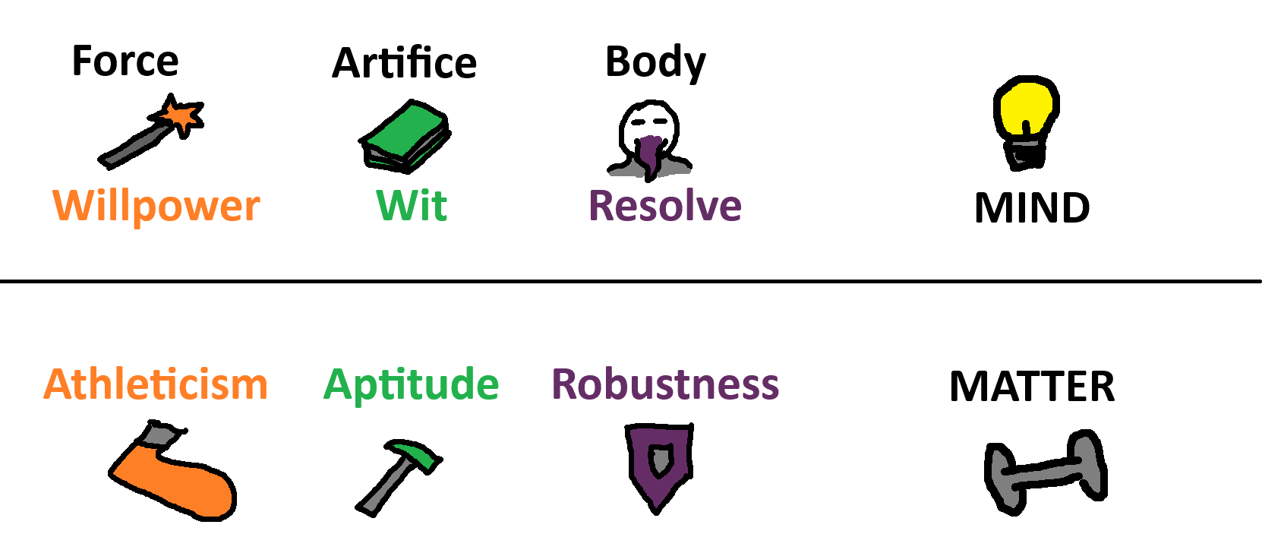
MATTER
Athleticism (ATH)
Athleticism represents the Force of MATTER. A body with high Athleticism can overpower others and handle intense physical challenges — a composite of speed, power, and forceful strength. Governs standard martial weaponry and raw combat force.
Aptitude (APT)
Aptitude represents the Artifice of MATTER - precise, skilled physical execution through which one manipulates the world. A body with high Aptitude is highly capable with tools and complex weaponry, excelling at any task demanding technical finesse.
Robustness (ROB)
Robustness represents the Body of MATTER - A body with high Robustness takes up space and absorbs blows without issue — a composite of endurance, hardiness, and functional strength. Governs brawler combat, physical endurance, and the body as a weapon.

MIND
Willpower (WIL)
Willpower represents the Force of MIND - the power through which one projects self into the world. A mind with high Willpower desires to actively write their will into reality, powering through obstacles if necessary. It presents itself as passion, fiery ambition, unapologetic authenticity, and single-minded drive.
Wit (WIT)
Wit represents the Artifice of MIND - the skill and craftsmanship through which one shapes the world. A mind with high Wit is adaptive and innovative, deftly maneuvering around situations before they become obstacles. It presents itself as intelligence, creativity, charisma, and an infinite toolbox of approaches to any problem.
Resolve (RES)
Resolve represents the Body of MIND - the resilience and focus through which one endures the world. A mind with high Resolve strives for the sense of self to weather any challenge that comes their way. It presents itself as discipline, fortitude, wisdom, and unshakable resilience.

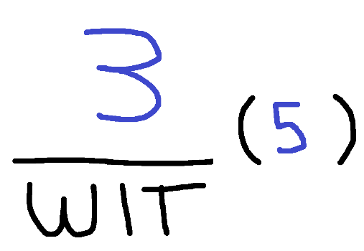
Facet Math
Each Facet is represented on one’s character sheet by the Effective Facet itself (the more prominent number) and a Raw Facet (the number in parentheses).
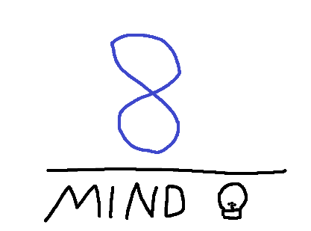
The Raw Facet – which begins at 1 – is determined on character creation and then continues to increment every few levels. This is simply a measure of progress and is used to calculate the Effective Facet by halving it and rounding it up.
The Effective Facet – which is shorthanded to simply the Facet in-game – is the actual value used to determine in-game outcomes for your character. The general scale is as follows:
An (Effective) Facet of 1 represents incompetence and will reliably yield poor outcomes if a situation tests that specific ability. Bringing a 1 into the midgame is considered a “dump stat”
A Facet of 2 represents some degree ability – granting below average but viable dice rolls. Many early-game characters will have a couple of 2’s in the Facets best suited to their Archetype
A Facet of 3 represents proficiency and competence and yields solid dice rolls. This is typically where abilities leveraging said Facet begin to feel potent, powerful, and reliable
Values 4 and onward are more incremental than the first three, but represent continued mastery and yield more consistent rolls approaching the ceiling as well reliable “critical hit” type effects. Points above 3 also grant resilience to debuff effects, which can be crippling if a 3 is decremented to 2 and a 2 to 1.

Mind & Matter Aggregates
On your character sheet, you will also find a field for MIND and another for MATTER listed directly alongside your Facets. These are determined by Aggregating your (Effective) facet values on each Axis. Therefore:
A character with Willpower 1, Wit 2, and Resolve 3 would have a MIND value of 6.
Athleticism 4, Aptitude 3, Robustness 4 would yield a hefty MATTER value of 11.
These broad values represent the interplay between different aspects of self. If one builds their Athleticism, it stands to reason that they gain some degree of Robustness and Aptitude on virtue of broad physical mastery. Similarly, one with High Wit becomes broadly sharper in a way that can overcome gaps in Willpower and Resolve. These aggregate values are used when determining defensive ability in combat as well as in the process of unlocking and properly utilizing specific feats and abilities.
One’s Facets and Prismatic Fingerprint are arguably the two most fundamental and guiding measures of a character. But now let’s get into more granular tests of skill and the ways in which Facets are leveraged.


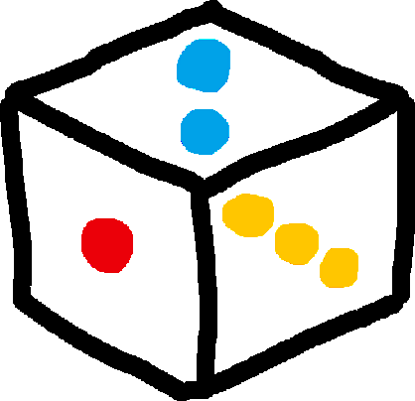

Checks
In the Prismatic Realm, you will face a variety of challenges — from fierce combat to tests of mind and body. Many of these carry uncertain outcomes, determined by a combination of random chance and your own Facets and Capabilities. These outcomes are resolved through a dice roll called a Check.

Rolling The Dice
A Check involves testing a specific Facet by rolling a number of six-sided dice.
The base number of dice you roll is equal to that Facet’s Effective Value.
Therefore, a character with a WIT of 4 would roll 4d6 for a “WIT Check”.
No fewer than 1 and no more than 3 dice are ever summed when determining the outcome of a Check.
This means:
- If you roll more than 3 dice, choose the three highest values and sum those.
- If an effect reduces your dice below 1, additional dice are instead rolled and only the single lowest value is taken. For example, a roll reduced by 1 would roll 2 dice and take the worst result.
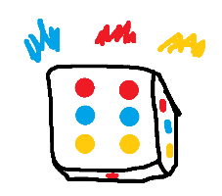
Prismatic Bursts
When fewer than 3 dice are rolled, rolling the highest possible value on any die triggers a Prismatic Burst — that die is re-rolled and added to the total, repeating until 3 dice have been rolled in total.
- On a 1d6 roll, rolling a 6 allows you to roll one more die and add it to the total. If that die also rolls a 6, a third and final die may be rolled and added in the same fashion.
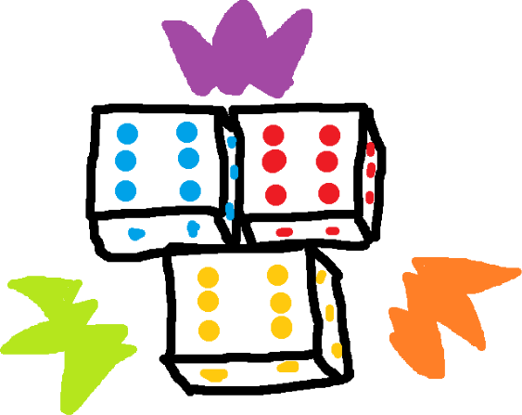
- On a 2d6 roll, if either die rolls a 6, one additional die is rolled and added to the total.

Prismatic Surge
If 3 dice — whether rolled at once or accumulated through Prismatic Bursts — land on their highest value simultaneously, a Prismatic Surge occurs. This represents a massive stroke of luck and inspiration: roll 3 additional dice and add the total to your result.
Because leveling a Facet beyond 3 d6’s allows you to choose the highest 3 values in the pool, continuing to hone your most potent qualities comes with the major benefit of more reliable Prismatic Surges.
Navigation (WIT) +d8
Intimidation (WIL / FORT) +d6
Though these additional dice may themselves trigger additional Prismatic Surges - no modifiers, abilities, or bumps may ever be applied to the additional dice to boost these odds

Bumping — Boons and Banes
Contextual conditions can increase or decrease the number of dice rolled in a Check through a process called Bumping:
- A Boon of X adds X dice to the roll, representing favorable conditions such as magical enhancements or proper equipment.
- A Bane of X removes X dice from the roll, representing hindrances such as crippling injuries or environmental obstacles.

Capability Checks
Some Checks test not just a Facet but a specific Capability — a trained skill tied to an underlying Facet. Each Capability on your character sheet is represented by a positive or negative annotation alongside a specific die type ranging from d4 to d20.
When a Capability is tested — such as the above Navigation check listed as NAV (WIT) +d8 — that die is rolled alongside your standard Facet dice and added to the total. A negative Capability die is instead subtracted from the total to a minimum result of 1.
Many Capabilities are Multifaceted – such as Intimidation listed above. This denotes skills which can be approached from two completely different angles. Intimidation through Force of will might involve being loud, boisterous, and angry – a show of mental willpower – whereas intimidation through Robustness would involve leveraging your imposing size and stature to achieve the same end. The Game Master may rule that one or the other is necessary in specific contexts, but by default Multifaceted Capabilities allow the player to choose which Facet is being checked.

The Assist Action
When making a Capability Check with enough time to reasonably seek help, another player or sufficiently intelligent creature may take the Assist Action. This can take one of two forms:
- Oversee — The Assistant takes a supervisory role, lending their expertise. Their Capability die is swapped into the Check in place of yours.
- Take Over — The Assistant steps in and performs the action directly. Their Facet dice are swapped in place of yours.
This dynamic makes it strategically valuable to develop Capabilities that may not align with your strongest Facets — a character with deep knowledge in a field can meaningfully contribute even when their raw ability is lacking, and vice versa.

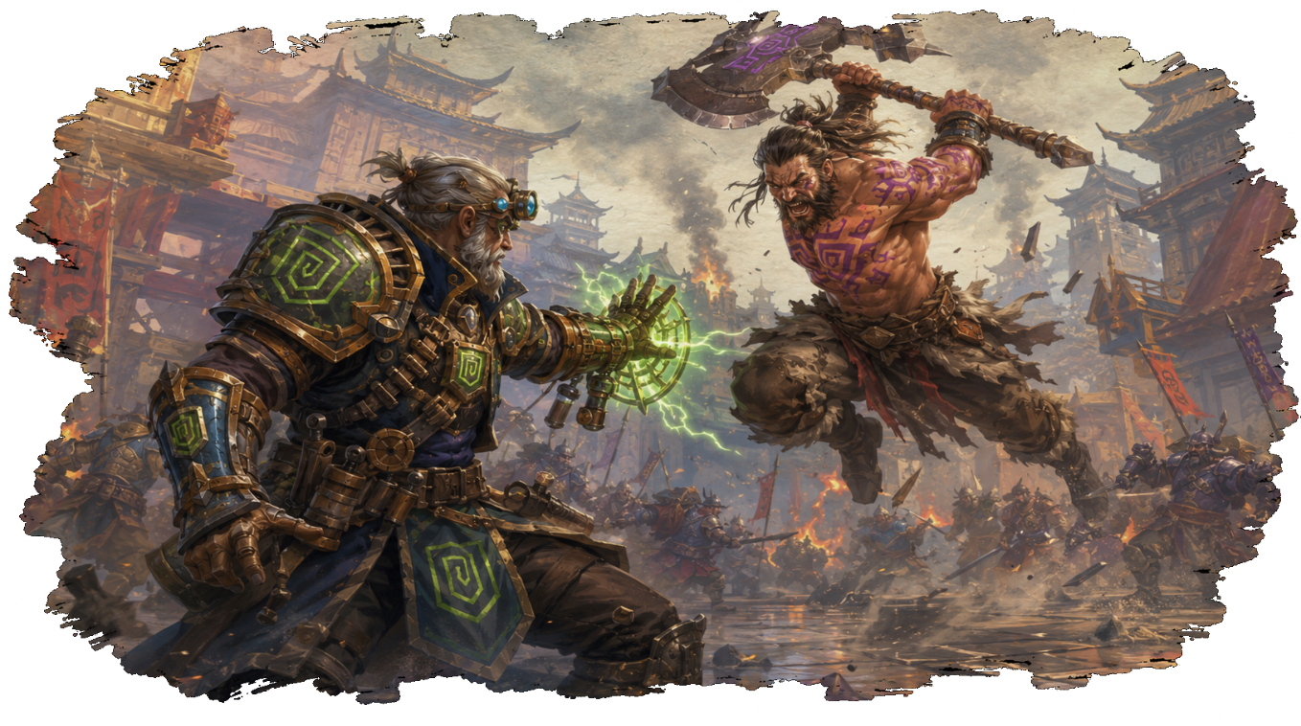
What is Battle?
Chapter 3
Battle
As you adventure through the Prismatic realms, you will inevitably meet those whose goals and attitudes directly oppose your own. These instances may be slight and resolved through diplomacy, but in the scenario where these differences escalate to blows, Battle is triggered.
When violence erupts, time snaps into focus. Battle is divided into sequential Turns - each one a 30-second window of real action, pressure, and consequence. Unlike Exploration or Downtime, every combatant acts in a specific order, choosing from their available actions before the moment passes to the next.
The entire sequence of every combatant’s turn is considered a Round of Battle. As soon as the final turn has ended, 30 seconds have passed and a new Round begins with the same turn order.
Battle begins when any of the following criteria are met:
- A hostile action (such as an attack or spell) is perceived by at least one member of the targeted party
- The Game Master determines that combat begins
- Events are likely to lead up to combat in a way that’s too tactical and granular for standard exploration-based gameplay
The Game Master ultimately makes the ruling on whether Battle Begins depending on the nature of their individual table. More narrative-focused groups might prefer to lean more toward narrative resolution unless combat is absolutely necessary, whereas more tactical groups might lean on Battles to accurately reach objective and granular conflict resolution.
Once a battle begins, it will naturally move toward a conclusion as events unfold over each round. The Game Master, once proper criteria have been met, will be able to declare its end. Battle formally ends when any of the following criteria have been met:
- A perception that all opposition has been Routed (Incapacitated or assumed to have escaped)

- All parties involved have mutually decided to de-escalate and stop fighting

- The Game Master has determined the remaining opposition poses no tactical or narrative stakes and continuing through combat may waste table time.
Criterion 3 should be used sparingly in service of the players’ experience. Players always retain Veto priority – if any player desires to continue combat, Battle does not end under this criterion.

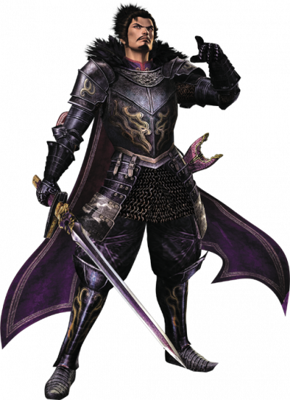
Combat Begins
When a Battle does begin, each combatant makes a Reflex (WIT/APT) capability check to determine the turn order of Battle.
Reflex checks are standard Capability Checks subject to Prismatic Bursts and Surges but receive a Boon or Bane equal to any amount of Haste or Stun tokens character brings with them into Battle. (See: Status Tokens).
After all Reflex Checks have been rolled and noted by the Game Master, Phases will be determined. A Phase represents a clustered set of turns where each belongs to a member of the same party. When multiple turns are in the same phase, they may be taken in any order desired by the combatants represented.
If disagreement arises regarding phases, players are to defer to the numerical turn order as the default.
Phases are often used to open up tactical possibilities – where an offensive player might want to allow a support player to act first and apply a buff to their next attack. They can also be leveraged to give indecisive players a chance to think without interrupting the table’s momentum.
Any combatant may choose to group into an allied Phase with a Reflex result lower than their own. A player who rolled a 19, separated from an ally who rolled 17 by an enemy who rolled 18, may prefer to act in the same Phase as their ally for the tactical flexibility it provides. Grouping may never be used to move up in turn order and may only be performed between Rounds once Battle is underway.
Phases require all members to be directly adjacent in the turn order. Any enemy turn between two allied turns — or any allied turn between two enemy turns — constitutes a Phase break. A single enemy who rolls between two allies splits what would otherwise be one allied Phase into two.
Note that Phasing and Grouping mechanics apply to GM-Controlled enemies as well as Player Characters. That Brigand whose turn appeared to be skipped may have simply grouped into an allied phase - coordinating with his companions rather than acting alone.
Once phasing and grouping have been mapped out, Battle will open with the first turn in the order. The turn of each combatant that is not a player character or explicitly under the control of a particular player (such as constructs or familiars) will be played by the Game Master.
When a Player Phase is reached, the Game Master will call out the names of all Player Characters within that Phase. A turn ends only when that player explicitly declares it complete, at which point the next combatant in the Phase - or the next turn in the order - may begin.

Actions
In Battle, your turn represents your actions taken over a 30-second window in the heat of the moment. Depending on the context, this may represent a 50-foot charge across a wide open battlefield, a flurry of blows directed at a foe, or tampering with machines and objects on the battlefield to turn the tide.
The number of actions that can be performed in this window varies drastically depending on the context and nature of said actions. A Barbarian might be able to swing his massive Battleaxe once in the same span of time a Thief runs across the field, slashes twice with a dagger, and ducks into cover. Similarly, a combatant focused entirely on sprinting across the battlefield in a hasty retreat may put everything they have into this explosive movement while a caster making a last stand might cast two mighty Prismatic incantations at the cost of moving at all.

Initiative Points ◆
The amount of energy, time, focus, and capability – the initiative - that can be directed toward taking action in this 30-second window is represented by a resource called Initiative Points, or IP (◆)
At the start of each turn, depending on Archetype and a variety of other factors, every character is granted a specific amount of IP ◆ that may be allocated toward performing actions. By default:
- Movement and object interactions expend ◆
- The average spell or attack expends ◆◆
There are many exceptions to this rule, which is denoted in the cost of those abilities.
Those that have a higher-than-average IP Expenditure generally require either an above-average amount of focus, time, or energy to perform. This might be a heavy weapon or mighty spell, where each use is generally higher impact than average.
Those that have a lower-than-average IP Expenditure generally require a below-average amount of focus, time, or energy to perform. This might be a light weapon or rudimentary spell, with a lower impact than average.
The same action or ability may be used as many times as you want so long as you are able to pay the resource costs each time. However, the IP Cost of a given action or ability increases by ◆ each time it is taken in a single turn. Therefore:
The first instance of movement on a turn will cost ◆
The second will cost ◆◆
The third will cost ◆◆◆
Note that Attacks and Spells are each considered the same type of action – where all spells increase the cost of other spells, and attacks increase the cost of other attacks. The most common amount of ◆ Generated per turn – or Maximum Initiative Points (Max IP ◆) is 4. This is typically enough initiative to:
- Move (◆)

- Attack or cast a spell (◆◆)

- Interact with an object or use a low-impact ability (◆)
There are many ways to modulate this value, however. Haste effects grant additional IP at turn start, while various Status Tokens (See: Status Tokens) might cripple and modulate the way they can be spent.
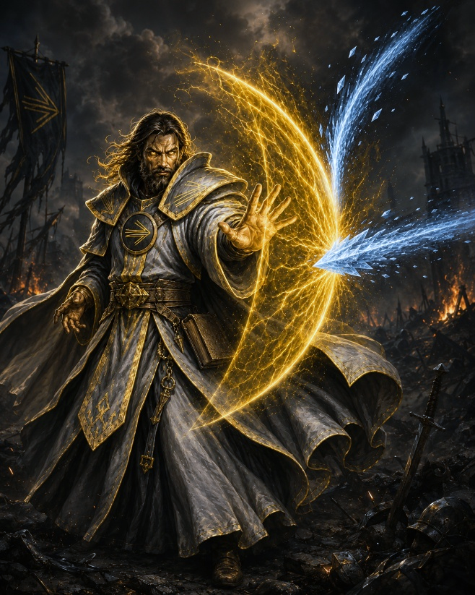
The most effective channelers take into account their own relationship with Initiative and build their strategy around it. It is often recommended to carry a healthy balance of low and high IP cost abilities to effectively handle a variety of scenarios. However, most archetypes will lean in one direction or the other and might discount or escalate IP costs in unique ways that suit their playstyle.
Finally, Speech is considered a Free action within reason (GM Discretion – it may require IP past a certain point if narratively impactful) and does not require IP so long as the character is not impacted by a condition that limits their ability to do so.

Reactive Initiative Points ◇
Many abilities specify Reactive Initiative Points, or R-IP (◇) as a primary or alternative cost.
All IP ◆ left over at the end of a given turn is retained as R-IP ◇ until the beginning of your next turn, where R-IP is reduced to zero.
R-IP ◇ may be used on any combatant’s turn as a reaction to a declared action or reaction.
A reaction must be declared before the outcome of the dependent action/reaction is known – before any dice rolls are made or mechanical resolutions are declared. Chains of Actions and Reactions follow a Last In-First Out Stack system, where the last reaction declared is the first resolved.
Reactions are most often seen in the form of flexible defensive maneuvers. Abilities of this nature are known as Disruptive Abilities, or Disruptions.
Morphic Disruptions are commonly seen in the form of force redirection, which change the direction of oncoming projectiles and evocations – potentially sending it at an entirely different target.
Entropic Disruptions are commonly seen in the form of force evaporation, or “fizzle” abilities. These dissolve incoming kinetic and prismatic damage, often converting it into temporary hitpoints and other resources.
Fabric Disruptions are commonly seen in the form of prismatic barriers – constructs of Prisma that act as literal barriers against oncoming attacks, often sticking around as battlefield cover or carrying some kind of utility with them.
Martial Disruptions are often abilities such as a thief’s combat roll granting a small amount of movement to avoid an oncoming attack or a duelist parrying a foe’s blade.
Offensive and Utility Reactions are also widely used and tend to mirror standard spells and attacks - typically with less potency for the added flexibility. These are known as Interrupting Actions, or Interruptions. Interruptions are a powerful way to protect allies or wait until information has been gathered to choose a specific target. They are also a great way to attack foes who were hidden on your turn – interrupting them with an attack as they go for a stealthy strike.
All R-IP ◇ costs may be paid in IP ◆ when performed on one’s own turn, but IP ◆ costs may never be paid in R-IP ◇
R-IP abilities, while inherently less potent and efficient than IP abilities, are a powerful tool in any Channeler’s Arsenal, and present a valid use-case for saving IP ◆ at the end of a given turn.
Many Archetypes heavily leverage these abilities to control the battlefield and proactively react to threats as a large part of their game plan. These Archetypes will also often include abilities which provide R-IP refunds and discounts between turns to empower this playstyle.

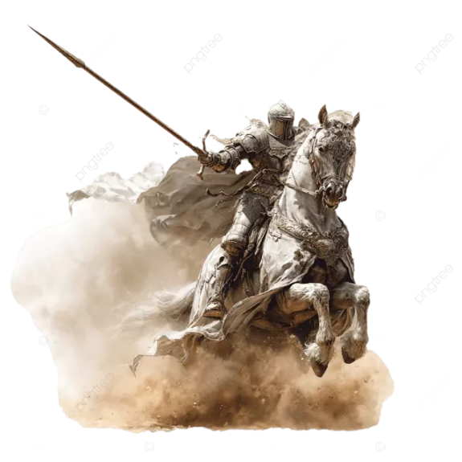

Movement
Nearly every Battle scenario will involve the elements of movement and positioning. A Warrior might charge across the field to close the gap between himself and a sniper. The sniper is searching for cover and weaving through the backlines of the fray. The thief dashes and rolls between hiding spots watching the whole thing go down.
Movement – or a Move Action – is initiative ◆ put toward traversing the battlefield.
A basic move action costs ◆ and grants movement equal to your character’s Speed. Speed is measured in Tiles, where each tile is equivalent to roughly 5 feet or 1.5 meters on the battlefield.
Larger Battlefields may require zooming out to be properly represented – in which case each tile might instead cost 2 or 3 Tiles’ worth of movement to traverse.
Most channelers have a base Speed of 4 tiles per Move Action – representing a rate of about 20 feet or 6 meters’ distance per Action.
This base value might differ depending on Race, Archetype, and various Feats and abilities that impact the rate at which a character moves through the world.
Additionally, all characters receive a 1-Tile movement speed increase for every Two points of Effective ATH they invest into, as the Facet of Athleticism governs the explosive movement seen on the field of battle.
Therefore, a standard character with an ATH of 3 would have a Base Speed of 5 Tiles, then a Base Speed of 6 Tiles after reaching an ATH of 5.

Upon making a Move Action, you are granted Remaining Movement equal to your character’s Speed for the duration of your turn. This movement may be used all at once, or spaced out between other actions and events throughout your turn. Move Actions add further Remaining movement to the total and are subject to standard Incrementing IP ◆ Rules. So, the first instance of Movement per turn will typically cost ◆, then ◆◆, then ◆◆◆. This means that a character with sufficient Initiative can put every ounce of energy and focus on massive feats of traversal, exhausting all IP ◆ in the process.
Any action which grants Movement of X Tiles follows these same general principle and adds to the same Remaining Movement Total unless explicitly noted in the action’s description.
The sole exception to this rule is any Reaction requiring R-IP ◇ granting additional Movement. In this case, all movement must be made at once upon the Reaction’s successful resolution, as Reactions are split-second maneuvers performed in response to something else happening. These are most commonly seen in the form of evasive maneuvers that allow a character to step out of the way of an oncoming attack, or aggressive parries granting an opportunity to approach the target attacker. Any unused Reactive movement immediately vanishes as soon as the movement itself is complete.

The condition of the Battlefield is also important to take into account when evaluating proper traversal. This may be in the form of Terrain, with the most common types being listed in the following table:
Terrain Reference Table
The majority of battlefield conditions establishing a Terrain will use some combination of the variants listed in the table above. Events that transpire during Battle might also create Terrain in the moment – where an Ice Spell might coat the ground with Slippery 3 Terrain and the destruction of a watchtower might create a patch of Obstructed Terrain. Using Terrain Tactically can mean the difference between a handy win and a crushing defeat.

Terrain | Effect | Examples
Obstructed | Movement through each Tile costs 2 Tiles of movement | Rubble, Large Rocks
Obscured (X) | Grants Boon of X on attempts to hide or move stealthily | Dense Trees, Patches of Darkness, Fog
Covered (X) | Has the properties of both Obstructed and Obscured (X) Terrain | Bushes, Empty Boxes and Barrels
Slippery (X) | Requires an APT Check equal to 5*X upon entry or turn start to avoid being knocked prone | Ice, Spilled Water, Oil Slicks
Prismatic | Grants localized effects depending on the nature of Prisma present | Area Spells, Leftover Residue from Exploded Prisma Storage, Natural Prisma Wellsprings
Treacherous (X) | Deals Damage of X against character’s absorption dice per Tile Moved | Lava, Spikes, Poison Swamps, Unstable Prisma Leakage
Blocked | Areas fully blocked off by physical objects | Walls, Large Trees, Prismatic Constructs
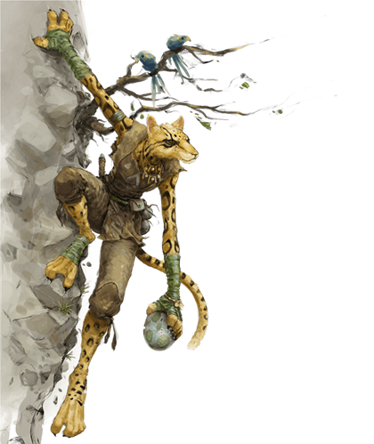
Special Movement
In the heat of battle, you might find yourself knocked prone, jumping across gaps, climbing walls, or swimming across bodies of water depending on the circumstance. These different methods of traversal all interact with your speed and remaining movement in different ways as follows:
- If you are Prone, half of your base speed must be used to Stand Up as a Free Action.

- You may Jump a distance in tiles equal to half your Effective ATH rounded up as a Free Action. Each tile jumped costs 2 Tiles of movement to use, and the start and end of the jump distance must be declared at the start of the jump.

- Swimming costs 3 Tiles of movement by default, though individual characters’ Swimming Speed as well as varying armor types may change this

- Climbing costs 1 Tile of Movement per 2 Tiles (~10 feet) climbed, though individual characters’ Climbing Speed may change this

- Flying Speed requires a Liftoff Action (Which costs ◆◆ by default) off the ground and grants movement equal to your Flying speed. Liftoff removes all remaining ground movement when performed. Movement Actions once aloft then function as normal, granting Tiles equal to your Flying Speed. Landing (whether intentional or unintentional) is a Free Action that removes all remaining flying movement.
It is also important to note that all Free Actions are valid targets for a combatant’s Reaction. This might result in a bloodthirsty foe targeting a character in the process of standing up, or a crafty caster creating ice right in the path of one jumping.
Falling and Landing are both treated as forced Free Actions that occur whenever a Climbing or Flying Creature via Limb Movement loses control of their relevant limbs (See: Status Tokens) while airborne. Therefore, an ally may use Reactions to cushion the fall or a foe might want to plant Treacherous Terrain in the path of a falling target.
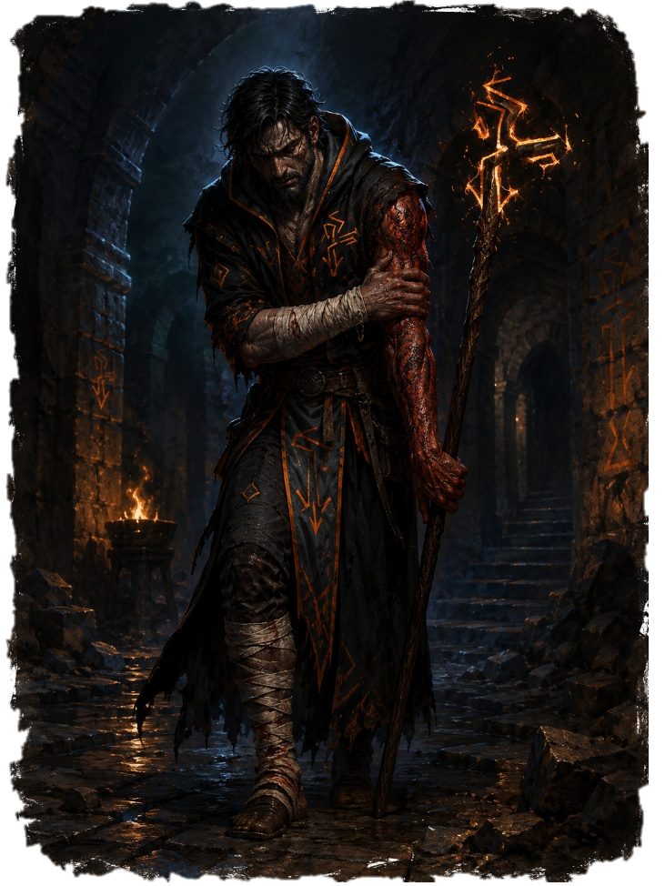
Base Falling Damage is calculated as follows:
Tiles Fallen | Base Damage | Feel
1 (5ft) | 1d4 (avg 2.5) | Stumble — barely relevant
2 (10ft) | 2d4 (avg 5) | Minor fall — stings
4 (20ft) | 4d4 (avg 10) | Serious fall — concerning
6 (30ft) | 6d4 (avg 15) | Dangerous fall — threatening
10 (50ft) | 10d4 (avg 25) | Severe fall — potentially lethal
20+ (100ft) | 20d4 (avg 50) | Catastrophic — almost certainly lethal

Falling onto Treacherous (X) Terrain adds X Damage on Impact for every Tile Fallen
Armor with the Heavy modifier doubles the summed Base + Treacherous Fall Damage
Once total Falling Damage is accounted for, this damage is rolled against Physical Absorption (See: Defensive Play) for the adjusted total.
Any fall of 2 or more tiles that deals damage causes a character to be knocked Prone upon Landing
Furthermore, any fall beyond 3 Tiles that deals damage causes a character to receive Stun X (See: Status Tokens) where X is equal to the number of tiles beyond 3 (4 Tiles = Stun 1, 6 Tiles = Stun 3)

Status Tokens
An Electrifying Morphic bolt leaps off the caster’s staff, stunning the fleeing knight and rendering him immobile. An Animated fireball sears the Artificer’s Arm – making even the slightest movements painful. The dazed scholar fails to put together the first words of an intended incantation.
While most traditional spell and weapon attacks incapacitate creatures by targeting hitpoints directly, many effects – both Martial and Prismatic – imbue debilitating Statuses that cripple them in various ways.
A Status is denoted by the name of the Effect followed by its Potency – such as Stun 5.
Statuses are separated into three tiers, each with its own section on the Character Sheet:
- Superficial Status
Temporary conditions which clear up on their own over time, decrementing by 1 at the start of each turn and clearing at the end of Battle.

- Lingering Status
More potent conditions as a result of excessive Superficial Status accumulation or more lethal status application. Clears on a long rest or with proper treatment

- Wounds
Visible and severe injuries that persist even along long rests. The result of excessive Lingering Status accumulation, and require skilled treatment
Applying the same type of Status within the same tier is additive – where Superficial Stun 3 applied to a character with existing Superficial Stun 2 results in a single instance of Superficial Stun 5.
When the Potency of a Status is greater than or equal to one’s relevant Integrity score, this is considered crossing the Status Threshold. This usually means that a Superficial Status becomes its Lingering Variant with a Potency of 1, or a Lingering Status becomes a corresponding Wound
Integrity is separated into Mental Integrity and Physical Integrity and calculated as follows:
Physical Integrity: Max IP + ROB
Mental Integrity: Max IP + RES
Therefore, a character with zero Resolve or Robustness investment and 4 Max IP sees a Status hit its threshold at a Potency of 5.
Statuses come in several different forms, with the most prominent being Initiative-Taxing Effects. This is described as Taxing an Action by X amount.
For example, Stun 3 imposes 3 Movement Tax. This means that as soon as a player with Stun 3 has 3 or less IP remaining, ◆ must be spent to use that IP for movement. IP that cannot be spent is known as Locked IP. In the case of this Movement Tax, 3 IP is Locked when movement is attempted, and each IP is unlocked by paying ◆
Therefore, a character with Stun 2 and 4 IP may spend ◆ at the start of their turn on a standard move action with no issues and have 3 IP Remaining. A second Move Action would normally increase and cost ◆◆. However, due to the Movement Tax imposed by the stun condition, this additional movement would instead cost ◆◆◆ to unlock the affected IP.
It is recommended that you keep track of Statuses using Physical Status Tokens alongside Physical IP Tokens to clearly track when a Status comes into play, as Initiative-Taxing effects under this paradigm come into play as soon as the IP Tokens are Equal to that type of Status Token.
There are dozens of different types of statuses that each impact a character in different ways.
However, there are several fundamental statuses that will be encountered by every Channeler as a part of their tactical toolkit. These fundamental statuses also tend to be correlated with body-part and elemental affinities, where targeting a specific limb or focusing on a certain type of Prismatic damage will commonly impose that specific status
Stun
Affinity: Electric Damage and Legs
Effect: Imposes Movement Tax of X
Threshold: Gain 1 Lingering Stun. Remove all Superficial Stun.
Wound: Paralysis or Dismembered Leg(s)
Weakness
Affinity: Necrotic/Poison Damage and Arms
Effect: Imposes Attack Tax of X
Threshold: Gain 1 Lingering Weakness. Remove all Superficial Weakness
Wound: Necrosis or Dismembered Arm(s)

Confusion
Affinity: Head and general blunt trauma
Effect: Imposes Spellcasting Tax of X
Threshold: Gain 1 Lingering Confusion. Remove all Superficial Confusion.
Wound: Concussion

Burn
Affinity: Fire Damage and Torso
Effect: Imposes Universal Tax of X. Must be paid with 3 Hitpoints per IP used.
Threshold: Gain 1 Lingering Burn. Remove all Superficial Burn.
Wound: Third Degree Burn or Organ Damage

Dazed
Affinity: Explosions and Mind-Targeting Effects
Effect: Imposes Tax on ◇ usage. Can be paid with ◇
Threshold: Gain 1 Lingering Dazed. Remove all Superficial Dazed.
Wound:

The Basics - Offense
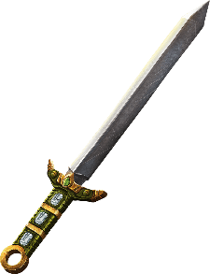
The rules of combat follow the same foundation as general capability checks, with several unique Nuances.
We’ll first want to establish the three primary “categories” of combat carried out by Prismatic Channelers, as these broadly determine the flow each turn will follow:

Martial Combat
Combat through Material Weapons and Physical Blows. Targets the body’s defenses directly - the Standard MATTER conception of combat
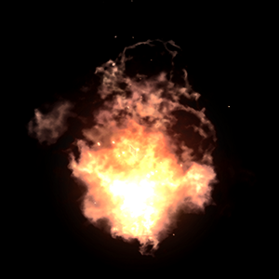
Prismatic Combat
Combat through Prismatic Spells and Abilities. Target mental and Prismatic defenses – the standard MIND conception of combat
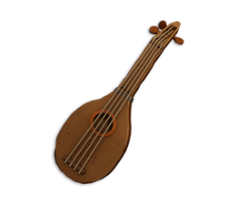
Utility Combat
Combat through support and utility, often dealing indirect damage, empowering allies, and crippling foes. MIND or MATTER depending on the context

Though most Archetypes tend to favor a particular game plan, most spell-slingers still carry a sidearm and the mightiest knights are able to lob some yellow Prisma in the form of a shock.
Let’s discuss the process of offense through each of these different lenses and the nuances of each.

Martial Combat
The nature of a Martial Attack depends primarily on the weapon wielded, and each comes with its own unique nuances.

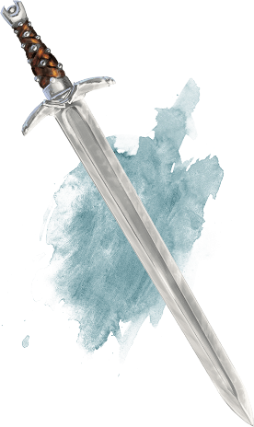
Morphic Longsword
Category: Versatile Class: Sword
Potency: d8
Traits: Reliable, Parry
Notes:
Applies 3 Stun when a Prismatic Surge lands.
● ● ◆ Deal Electric Damage and apply Stun equal to Sword Proficiency upon dealing damage

Standard Attacks
Firstly – each Weapon or Damaging Spell has:
- A Specific Potency Die ranging from d4 to d20
- A Reliant Facet
- A Category tied to proficiency level
When a spell or weapon attack is declared on a target (or multiple targets), dice are rolled in similar fashion to a standard Check. Unlike Checks, however, the type of die rolled is that attack’s Potency Die. A longsword with a potency of d8, for example, would roll N d8’s to make the attack.
When making a weapon attack, the number of Dice Rolled is directly determined by that weapon category’s proficiency tier. A die is rolled for each proficiency level, so a Dagger with d4 potency and Proficiency 2 would be a 2d4 roll. The reliant Facet is then added to the total – so in the dagger’s case, an Aptitude of 3 would add 3 to the damage dealt.
Proficiency Tiers are often accumulated as one levels up and reaches certain Facet Breakpoints – where Dagger Proficiency 3 might require an Effective Aptitude of 4, for example. As with Checks, the number of dice summed is never fewer than 1 or greater than 3 regardless of how many are rolled. Prismatic Bursts and Surges are also applied in the same fashion – where rolling the highest value on a particular die adds an additional die up to 3, and rolling the highest value 3 times grants 3 additional dice.
Weapon proficiency past 3, therefore, serves to more reliably dish out more damage and consistently achieve Prismatic Surges as opposed to endlessly raising the damage ceiling.

Spell attacks, on the other hand, are determined by description of the spell itself, but generally follow three common trends:
- Static Effects with a predictable Prisma Cost. A Morphic Bolt that deals 1d8 damage for 3 Yellow Inklings every time.

- “Pump” spells with an X in the Prisma cost, which often deal damage in scaled with Prisma Expenditure. A Pump Spell that costs X Red Inklings might deal Xd4 damage depending on how many Red Inklings are channeled

- Archetypal Spells that Scale with specific breakpoints or Facets. These are particularly common in Archetypes which imbue weapons with Prisma or conjure Prismatic Weapons

Regardless of the exact nature, the attacker always rolls damage after declaring an attack, choosing target(s), and paying the resource costs associated. The Defender then compares the Attack Damage with their Armor to determine the next step

Standard Defense
Defense is determined by a character’s MIND/MATTER, Armor, and Shield (if applicable). This is in the form of a few very important values:
- Physical Defense (PHYS-DEF) and Mental Defense (MENT-DEF)
- Mental and Physical Absorption Dice
- Any existing Hitpoint buffers, known as Armor Points (AP)
Each Defense first determined by taking the corresponding Stat
PHYS-DEF => MATTER,
MIND-DEF => MIND
This means that a character with zero investment has an absolute floor of 3 PHYS-DEF and 3 MIND-DEF.
Each Armor Set then has its own MIND and MATTER associated with it, which is added to this value. Therefore, a character with 8 MATTER wearing a heavy set of armor providing another 7 MATTER has a total PHYS-DEF of 15.

All incoming Damage targets one of these two defenses – where martial and material projectile attacks target PHYS-DEF and Prismatic Attacks target MIND-DEF. If the incoming damage is below the base defense value, the attack is fully blocked, avoided, or warded off – it fails to pierce the target’s baseline defenses.

If the Damage is above this threshold, however, the defender rolls their Absorption Dice to determine how much damage they take. Every Set of Armor and Shield has its own associated Mental and Physical Absorption Dice, and choosing to wield a shield will grant the shield’s Absorption Dice as well. Several spells and abilities – such as Prismatic Auras, Countermagic, and Projectile Redirection – will often grant additional absorption dice as well.
Only Armor Absorption Dice are subject to Prismatic Bursts and Surges, however, and follow the same rules as Checks and Attacks.
The outcome of the absorption roll is directly subtracted from the amount of incoming damage – with the potential to negate the damage entirely on a lucky roll.

Every Archetype and fighting style has its own relationship with Defense and Absorption, as well as a preference for Physical Defense and Mental Defense. Generally speaking:

High Base Defense is great at tanking repeated blows and weathers long fights effectively. Has zero reliance on luck or resource expenditure. Particularly effective against fighting styles that leverage a high volume of chip damage that fails to break the threshold.
Defense has a lower ceiling but more reliability

High Absorption is great at reacting to explosive damage and going toe-to-toe with an attacker’s offense as needed. Absorption is often synergistic with dice luck and effects that empower rolls or add additional absorption dice. Particularly effective against fighting styles that leverage singular explosive instances of damage.

Initiative Points (IP)
In the heat of combat, only so many actions can be taken over the course of several seconds each turn. A lumbering Invigorated Fighter might cleave with a Great Axe in the same span of time it takes a thief to swing thrice with his dagger, and a terrified fleeing foe might put all his energy and mind toward moving and escaping the battlefield.

The amount of things that can be done in a turn is represented by a resource called Initiative Points, represented by a Diamond Icon ◆. Each Archetype has its own Maximum amount of Initiative Points that is generated at the start of each turn – with the standard amount being 4.
Each action in combat has an IP Cost. Movement uses 1, Attacks and Spells 2, Object Interactions 1.

